**CHAPTER 1**

**INTRODUCTION**

### 1.1 General Introduction

In today’s fast-paced lifestyle, maintaining healthy skin has become a growing concern for individuals across different age groups. Skincare routines vary widely depending on factors such as skin type, diet, environmental conditions, lifestyle habits, and product usage. While dermatologists and skincare experts provide professional guidance, not everyone has regular access to such personalized consultations. This gap has created the need for **technology-driven skincare solutions** that are affordable, accessible, and effective.

The project **GLOWCARE** addresses this challenge by providing a **machine learning-based skincare recommendation system**. The system focuses on predicting suitable **morning and evening skincare routines** for users based on their personal and lifestyle data. By analyzing a structured set of questionnaire responses, the system generates customized routines that align with individual skin needs.

The dataset used for this project contains **1,200 entries with 22 attributes**, including skin type, water intake, diet pattern, sun exposure, cleansing frequency, sleep duration, stress level, and awareness of skincare habits. The target variables are **Morning Routine** and **Evening Routine**, which define the sequence of skincare products and steps suitable for each user.

To ensure effective prediction, the **Random Forest algorithm** has been implemented. This ensemble learning technique provides high accuracy by combining multiple decision trees and minimizing the chances of overfitting. The algorithm is well-suited for handling both categorical and numerical features present in the dataset.

The system is deployed as a **web-based application**, allowing users to **register, log in, and fill out questionnaires**. Based on whether the user is new or existing, the model adapts the routine accordingly. This ensures that recommendations are not only data-driven but also personalized over time.

**1.2 Objectives of the Project**

### The main objective of the project GLOWCARE is to design and implement a web-based machine learning system that provides personalized skincare recommendations. The system focuses on predicting suitable morning and evening skincare routines based on user-specific data.

### The specific objectives are:

### To develop a machine learning model using the Random Forest algorithm for accurate prediction of skincare routines.

### To create a user-friendly web application with login and registration features for secure and easy access.

### To design questionnaires that collect relevant lifestyle and skin-related data from both new and existing users.

### To recommend personalized morning and evening skincare routines tailored to each individual’s skin type, habits, and environment.

### To provide separate workflows for new and existing users, ensuring that past data is utilized for improved accuracy in recommendations.

### To integrate machine learning with real-world skincare practices, highlighting the role of technology in self-care and wellness.

### 1.3 Existing System

### In the existing scenario, skincare recommendations are primarily obtained through dermatologists, beauty consultants, or online resources. While professional consultations provide accurate guidance, they are often costly, time-consuming, and not easily accessible to everyone. On the other hand, general skincare tips available online are not personalized and may not suit an individual’s unique skin type or lifestyle habits.

### Some mobile applications and websites provide skincare advice, but most of them are either generic in nature or rely on predefined skin categories without using advanced machine learning models. This often leads to recommendations that lack accuracy and fail to address the specific needs of users. Furthermore, existing systems generally do not differentiate between new users and returning users, limiting the adaptability of recommendations over time.

### 1.4 Proposed System

The proposed system, **GLOWCARE**, is designed to overcome the limitations of existing systems by integrating **machine learning with a web-based platform**. The system uses the **Random Forest algorithm** to predict customized **morning and evening skincare routines** for users.

Key features of the proposed system include:

* A **login and registration module** for secure access.
* A **structured questionnaire** to collect skin and lifestyle-related inputs.
* Separate workflows for **new users** (based on fresh inputs) and **existing users** (using past data for refined recommendations).
* Machine learning-based predictions that are more **personalized and accurate** than generic suggestions.
* A simple, user-friendly interface that makes it easy for individuals to access their personalized skincare plan.

### 1.5 Feasibility Study

### The feasibility study evaluates whether the proposed system can be developed and implemented successfully. It includes the following aspects:

### - Technical Feasibility

### The project is technically feasible since it uses widely available tools such as Python, Random Forest algorithm, Flask/Django (for backend), and HTML/CSS/JavaScript (for frontend).

### The dataset is clean, well-structured, and suitable for machine learning applications.

### Hosting and deployment can be done on affordable cloud platforms.

### Social Feasibility

### The system is socially feasible because it addresses a common concern—maintaining healthy skin. Many people struggle to find routines that suit their skin type and lifestyle. GLOWCARE provides affordable, accessible, and personalized skincare guidance, which increases acceptance among users. Since the system is easy to use, it can benefit people from different age groups and regions.

### Operational Feasibility

### The system is operationally feasible as it is simple, user-friendly, and requires no technical knowledge from the users. By answering a set of basic questions, users can instantly receive their morning and evening skincare routines. The web interface with login and registration ensures smooth usage, while the machine learning model guarantees accurate and reliable recommendations.

### CHAPTER 2

* 1. **REVIEW OF LITERATURE**

Skincare recommendation systems and wellness applications have been an emerging area of interest in recent years. With the growth of artificial intelligence and machine learning, several research works and applications have attempted to provide personalized health and skincare guidance.

* **Traditional Approach:** In the past, skincare recommendations were mostly based on general tips available through beauty blogs, magazines, and online forums. These methods were not data-driven and provided only generic advice.
* **Machine Learning in Healthcare:** Recent studies have shown that machine learning algorithms such as **Decision Trees, Random Forests, Support Vector Machines (SVM), and Neural Networks** are effective in analyzing lifestyle and health-related data. These models help in predicting outcomes and suggesting personalized solutions.
* **Wellness Applications:** Some mobile and web-based wellness apps provide skincare or health tips, but most of them either rely on **predefined rules** or simple questionnaires without intelligent prediction models. As a result, the recommendations lack depth and personalization.
* **Gap in Existing Systems:** Many existing systems fail to distinguish between **new users** (with no prior data) and **existing users** (with past records). This reduces the adaptability and long-term effectiveness of such applications.
* **Proposed Contribution:** The project **GLOWCARE** addresses this gap by implementing a **Random Forest-based model** trained on a dataset of 1,200 records with 22 features. By combining machine learning with a user-friendly web interface, the system generates **personalized morning and evening skincare routines** for both new and existing users, making it more practical and effective compared to traditional or generic approaches.

**CHAPTER 3**

* 1. **SYSTEM CONFIGURATION**

**3.1 Hardware Requirements**

* **Processor:** Intel i3 or above
* **RAM:** Minimum 4 GB (8 GB recommended)
* **Hard Disk:** 250 GB or more
* **Display:** Standard Monitor with 1024x768 resolution
* **Internet Connection:** Required for web access and deployment

**3.2 Software Requirements**

* **Operating System:** Windows / Linux / macOS
* **Programming Language:** Python 3.x
* **Backend Framework:** Flask / Django
* **Frontend:** HTML, CSS, JavaScript
* **Database:** MySQL / SQLite
* **Libraries:** Pandas, NumPy, Scikit-learn, Matplotlib
* **IDE / Tools:** VS Code / PyCharm / Jupyter Notebook
* **Browser:** Google Chrome / Mozilla Firefox

**CHAPTER 4**

* 1. **MODULES DESCRIPTION**
  2. **4.1 Modules**

The Glowcare system is divided into several modules, each handling a specific function of the skincare recommendation process. The modular design makes the system easy to understand, scalable, and efficient. The following are the key modules of the system:

**4.1.1 User Authentication Module (Login & Registration)**

This module provides secure access to the system.

* New users can register by providing their personal details such as name, age, gender, email, and password.
* Existing users can log in using their credentials.
* It ensures only authorized users can access personalized skincare recommendations.

**Functions:**

* User Registration
* User Login
* Session Management

**4.1.2. Questionnaire Module**

This module collects data from users to understand their skincare needs.

* **New Users:** A questionnaire form is displayed to collect skin type, skin concerns, and lifestyle factors.
* **Existing Users:** Their previous questionnaire data is retrieved from the database to avoid re-entry.

**Functions:**

* Display questionnaire to users
* Store responses in the database
* Retrieve responses for existing users

**4.1.3. Machine Learning Prediction Module**

This is the core of the system where the **Random Forest algorithm** is applied.

* The algorithm processes the dataset along with questionnaire inputs to predict suitable skincare routines.
* It classifies the data into **morning** and **evening routines**.
* Provides recommendations that are dynamic and based on the latest user input.

**Functions:**

* Fetch user responses from the database
* Apply Random Forest algorithm
* Predict morning and evening routines

**4.1.4 Routine Recommendation Module**

This module displays the personalized skincare routine to the user.

* The routine is separated into **morning** and **evening** sections.
* Each step includes brief notes on how to use the recommended product or skincare step.
* For existing users, the routine may evolve over time based on feedback.

**Functions:**

* Display personalized morning routine
* Display personalized evening routine
* Update recommendations dynamically

**4.1.5 Progress Tracking Module**

This module helps users monitor their skincare journey.

* Users can provide feedback about their skin condition after following the routine.
* The system stores progress history and satisfaction levels.
* Over time, this data can help refine recommendations.

**Functions:**

* Store progress feedback
* Maintain history of skincare improvements
* Link feedback with routine adjustments

**CHAPTER 5**

* 1. **SYSTEM DESIGNS**

**5.1 Data-flow diagram**

**DFD Diagram (Level-0):**

In this diagram, the system interacts with two main external entities: the new user and the returning user. The new user provides registration details and fills out the skincare questionnaire, which flows into the GlowCare system. Similarly, the returning user logs in and submits updated skincare details through the questionnaire. Both sets of inputs are processed by the system, which communicates with its internal databases, such as the user database for authentication and the questionnaire database for storing responses. Based on the inputs, the system applies its predictive models to generate personalized skincare routines. The processed results, in the form of morning and evening skincare recommendations, are then sent back to the respective users. Thus, the Level 0 DFD captures the overall flow of data between users, the Glowcare system, and its data stores, without going into internal processing details, giving a clear picture of the interaction at the topmost level.

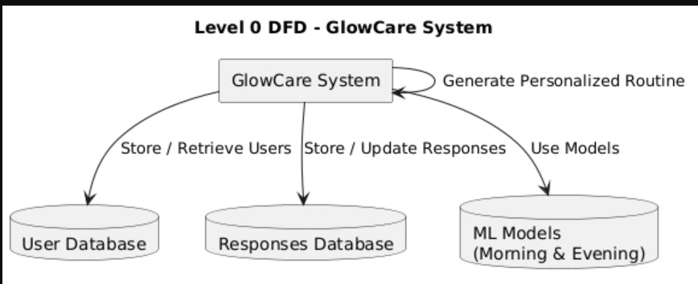

**Figure 5.1.1 DFD level 0**

**DFD Diagram (Level-1):**

The Level 1 DFD of the Glowcare (Skincare Recommendation System) expands the single process in Level 0 into detailed sub-processes. For new users, the flow begins with registration and authentication, followed by the new user questionnaire, where responses are stored in the database and processed by the prediction engine to generate personalized routines. For returning users, the login process validates credentials, then the returning user questionnaire captures updated skincare details, which are again passed to the prediction engine. Finally, the result generation process formats and displays the personalized morning and evening skincare routines. This level highlights how user data, questionnaires, prediction models, and result generation interact to deliver tailored recommendations.

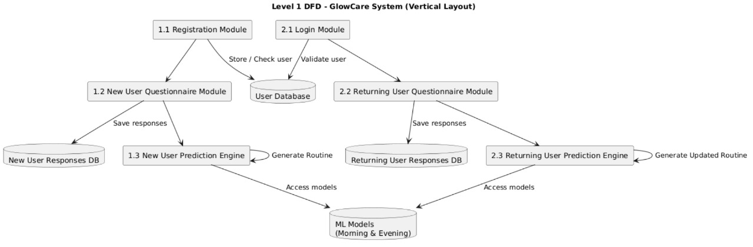

**Figure 5.1.2 DFD level 1**

**5.2 Use case diagram:**

The use case diagram for the Glowcare (Skincare Recommendation System) illustrates how different users interact with the system and the major functions it supports. There are two primary actors: New User and Returning User. A new user begins with the registration process and then proceeds to the login use case. After logging in, they access the new user questionnaire, whose responses are stored in the system and analyzed by the recommendation engine to produce a personalized morning and evening routine. A returning user directly uses the login use case, after which they can fill out the returning user questionnaire to update their skincare information. Their data is also processed by the recommendation engine to generate updated routines. Both actors can view their results. This diagram clearly shows how GlowCare supports user authentication, data collection, prediction, and routine delivery, ensuring a smooth flow for both first-time and repeat users.

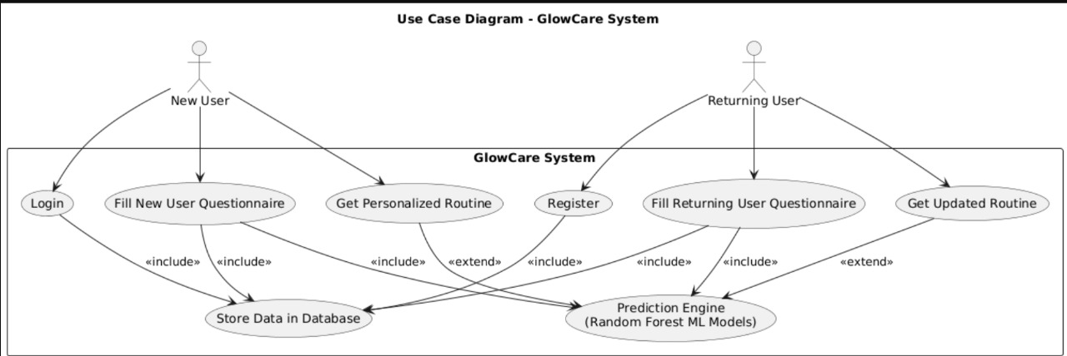

**Figure 5.2.1 Use-case diagram**

**CHAPTER 6**

* 1. **SYSTEM IMPLEMENTATION**
  2. **6.1 Implementation**

System implementation is the process of converting the designed model into a working application. In the project GLOWCARE, implementation was carried out in multiple phases to ensure smooth development and functioning.

**Dataset Preparation**

The dataset with 1,200 records and 22 features was preprocessed.

Categorical values such as skin type, diet, and sun exposure were encoded.

Numerical features such as water intake, age, and sleep hours were normalized.

**Machine Learning Model**

The Random Forest algorithm was used to train the model.

The dataset was split into training and testing sets for evaluation.

The model was tested to ensure accuracy in predicting Morning and Evening routines.

**Backend Implementation**

The backend was developed using Python Flask/Django.

Routes were created for user login, registration, questionnaire, and routine prediction.

The ML model was integrated with the backend for real-time prediction.

**Frontend Implementation**

The frontend was designed using HTML, CSS, and JavaScript.

User-friendly forms were created for login, registration, and questionnaire input.

Results were displayed in a simple and easy-to-read format.

**Integration and Testing**

The backend and frontend were connected to form the complete web application.

Functionality was tested for both new users and existing users.

Predictions were validated to ensure the system provided relevant skincare routines.

**Deployment**

The system was deployed on a web server for user access.

The web application is accessible via any modern browser.

* + - The implementation ensured that the system works seamlessly, providing users with personalized, accurate, and instant skincare recommendations.

**6.2 Screenshots:**

**6.2.1 Home page**

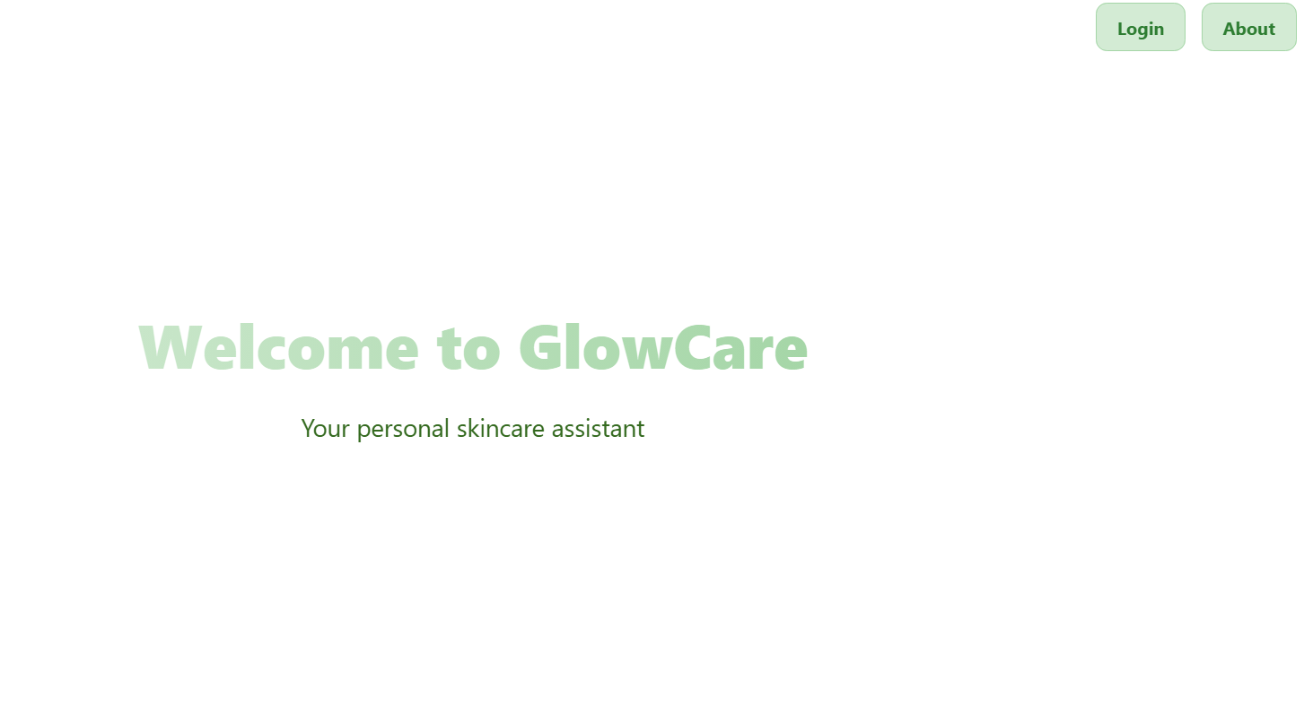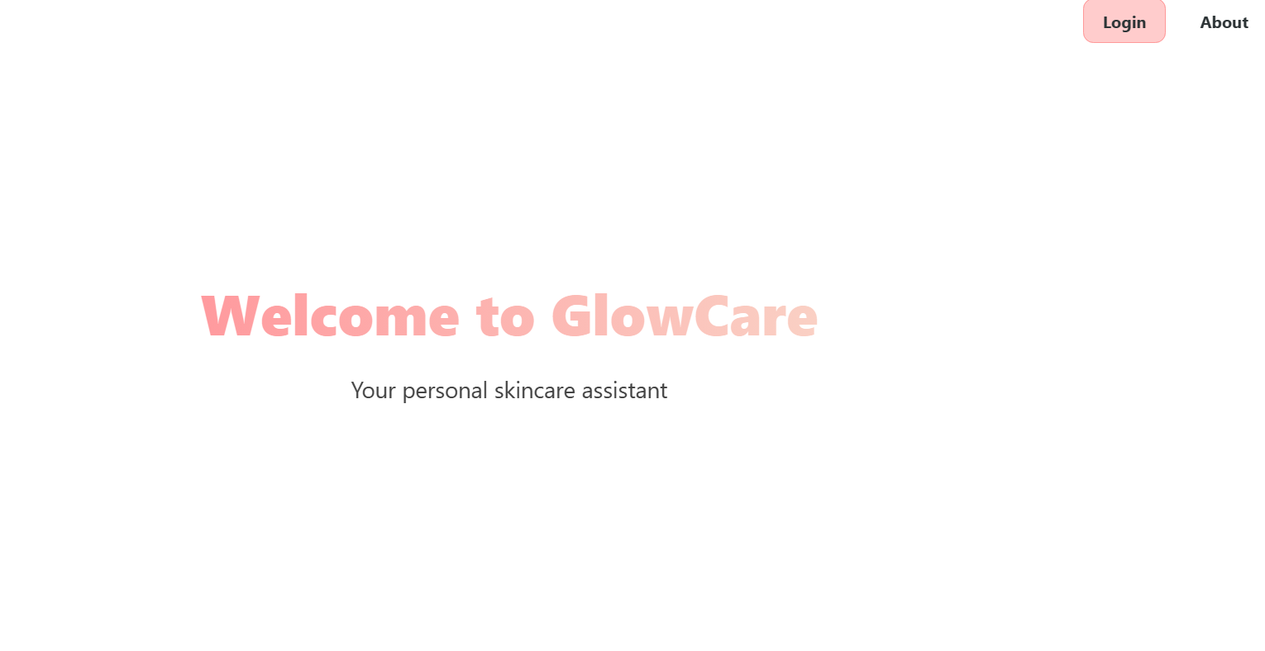

**Figure 6.2.1 Home page**

The home page of GlowCare provides a clean and minimal interface, welcoming users to their personal skincare assistant with options to log in and learn more.

**6.2.2 About page**

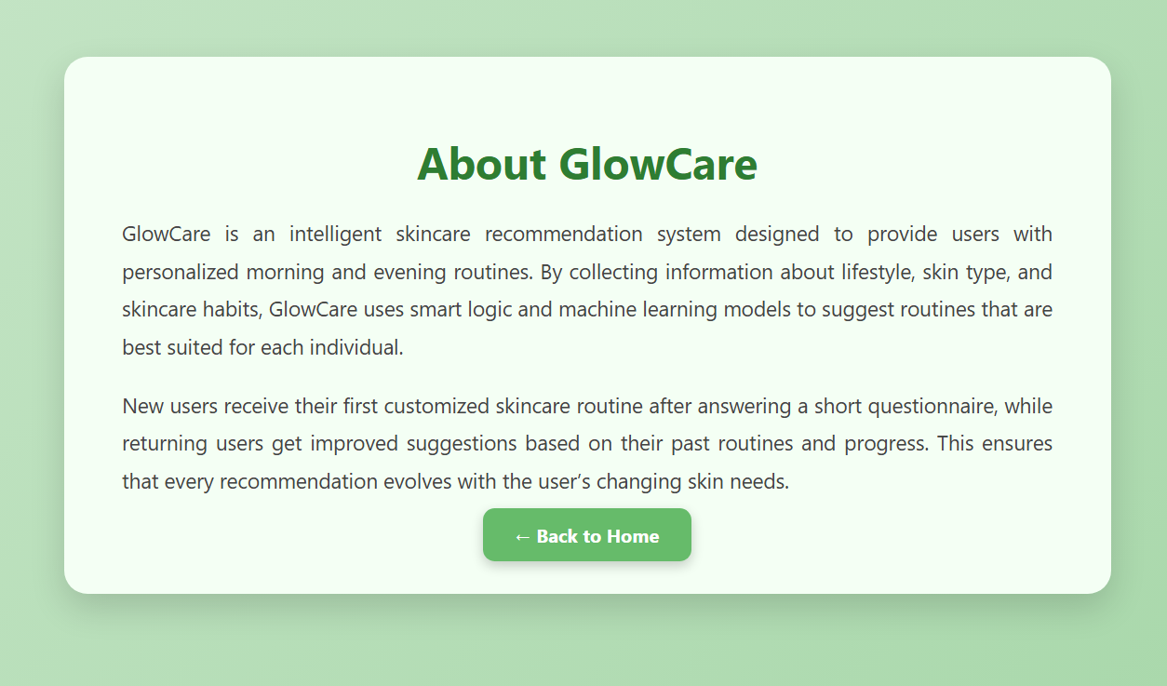

**Figure 6.2.2 About page**

The About page explains the purpose of GlowCare, showing how it provides personalized skincare routines using user information and smart recommendations.

**6.2.3 User type page**

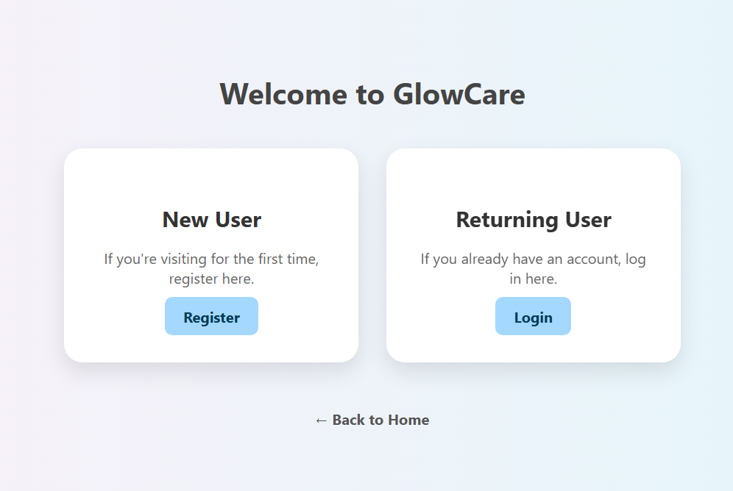

**Figure 6.2.3 User type page**

The User Type page allows new users to register for the first time and returning users to log in with their existing account.

**6.2.4 New user registration page**

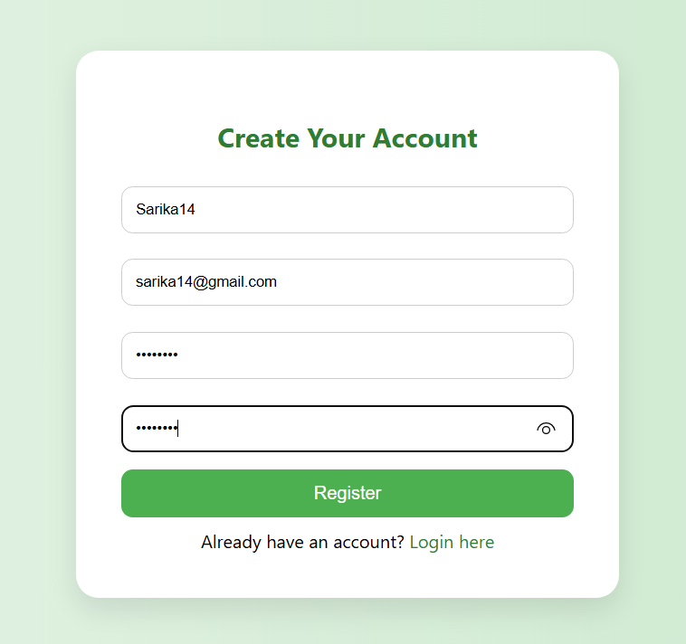

**Figure 6.2.4 New user Registration**

The New User Registration page lets users create an account by entering their name, email, and password.

**6.2.5 New user login**



**Figure 6.2.5 New user Login**

The User Login page allows registered users to log in securely using their username and password.

**6.2.6 New user Questionnaire**

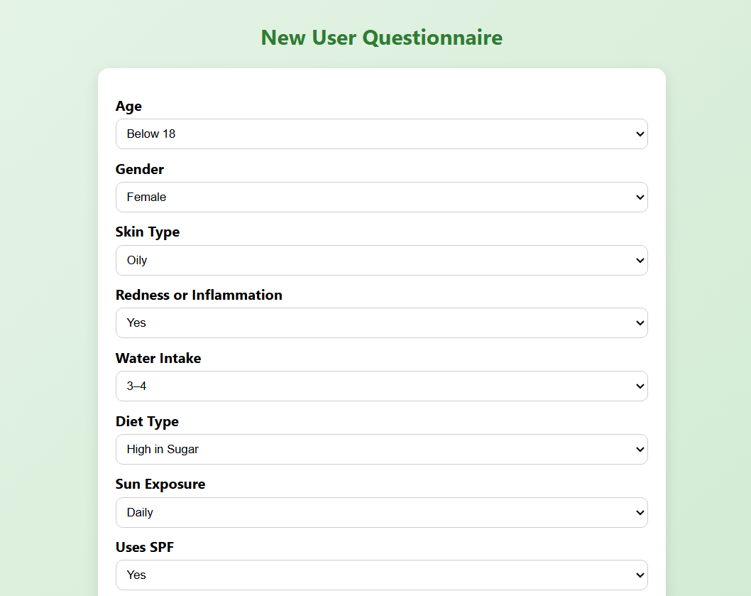

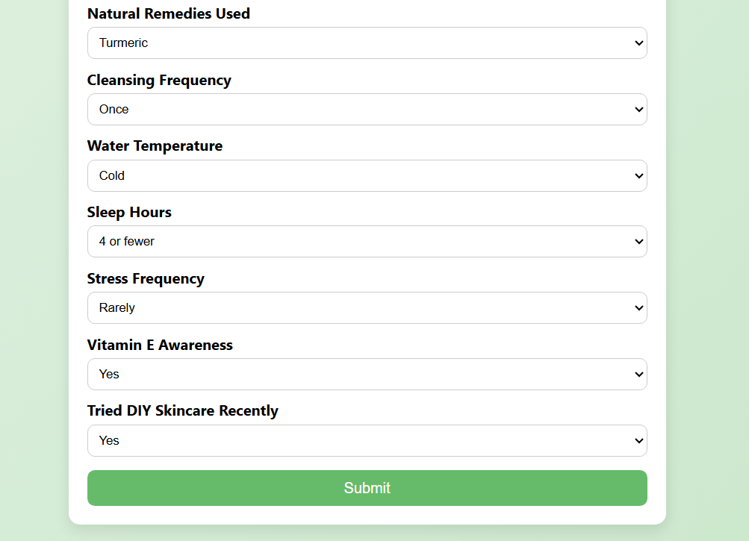

**Figure 6.2.6 New user questionnaire**

The New User Questionnaire page collects details like age, skin type, lifestyle, and skincare habits.This information helps the system generate personalized skincare recommendations.

**6.2.7 New user result page**

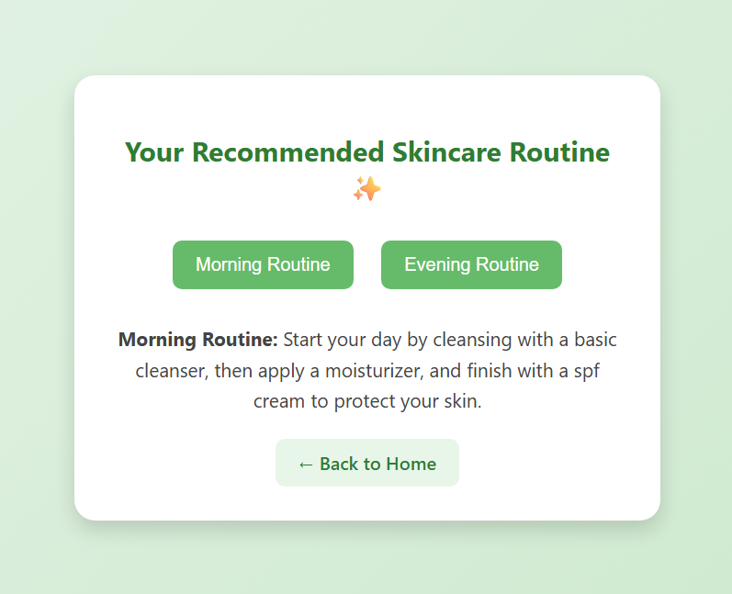

**Figure 6.2.7 New user result**

The New User Result page displays a personalized skincare routine, giving morning and evening care suggestions based on the user’s inputs.

**6.2.8 Returning user login**

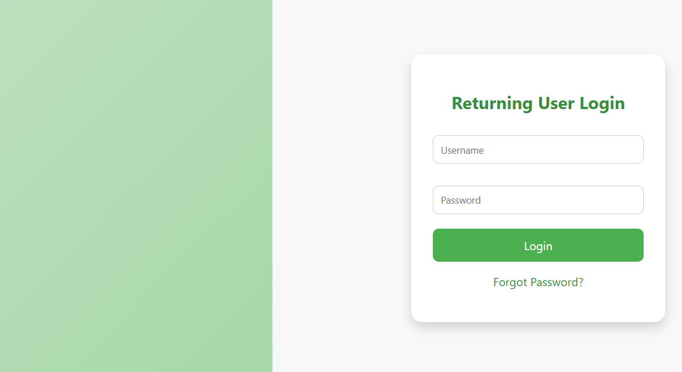

**Figure 6.2.8 Returning user login**

The Returning User Login page allows existing users to log in securely by entering their username and password. It also provides a ‘Forgot Password?’ option for account recovery.

**6.2.9 Returning user Questionnaire**

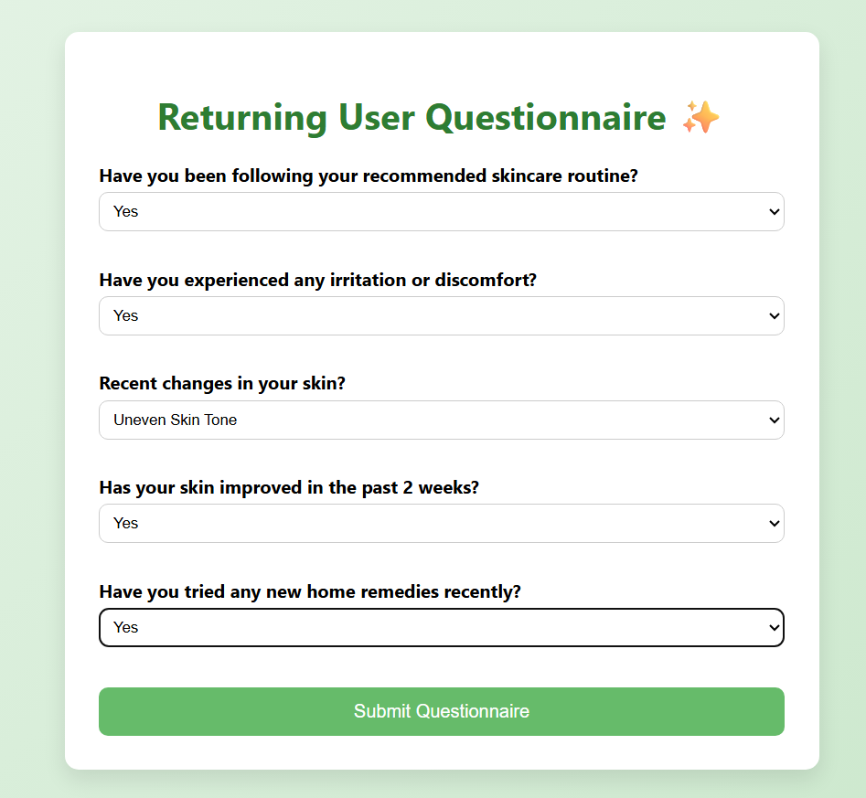

**Figure 6.2.9 Returning user questionnaire**

This follow-up questionnaire helps assess your adherence to the recommended skincare routine, track any skin changes or issues, and evaluate the effectiveness of the regimen over the past two weeks.

**6.2.10 Returning user result page**

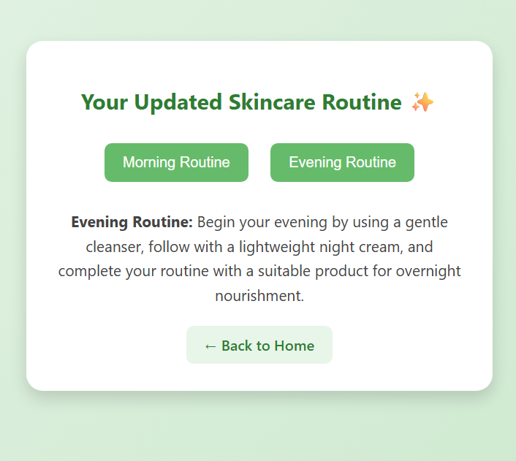

**Figure 6.2.10 Returning user result**

The result page shows an updated skincare routine, with separate steps for morning and evening. It helps users follow the right products based on their skin needs.

**6.2.11 Forgot password page**

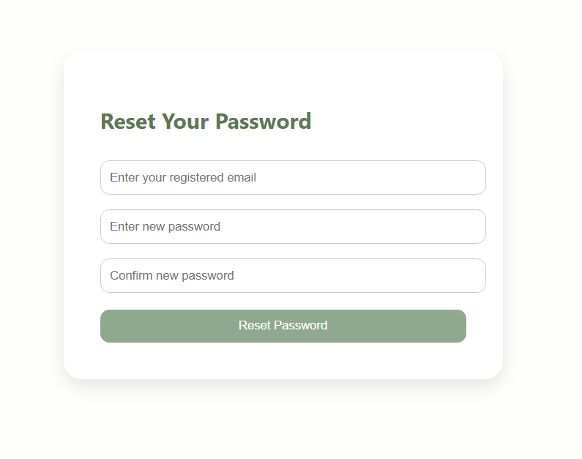

* 1. **Figure 6.2.11 Forgot password**

The Forgot Password page helps users securely reset their password by entering their registered email, choosing a new password, and confirming it before submitting.

**CHAPTER 7**

## ****SYSTEM TESTING****

System testing was carried out to verify the correct functioning of all modules in the **GLOWCARE** application. The purpose of testing was to ensure that the system works smoothly, produces accurate predictions, and meets user requirements. Different testing methods such as **Unit Testing, Integration Testing, and User Acceptance Testing (UAT)** were performed.

The **registration and login modules** were tested to confirm that users could create accounts, log in with valid credentials, and receive error messages for incorrect inputs. The **questionnaire module** was checked to ensure that all skin and lifestyle data entered by users were properly collected and passed to the machine learning model. The **Random Forest prediction model** was validated to confirm that it generated accurate morning and evening skincare routines for both new and existing users.

Test cases also included scenarios such as submitting incomplete questionnaires, where the system correctly displayed error messages like “Please fill all required fields”. In addition, the **system response time** was tested to ensure that results were displayed within a few seconds after submission. Overall, the test cases showed that the system successfully handled all expected inputs and produced reliable results, making it operationally stable and user-friendly.

**Table 7.1 System Testing Test cases**

**User Registration page**

|  |  |  |  |  |
| --- | --- | --- | --- | --- |
| **Test cases** | **Input** | **Validation** | **Output** | **Test** |
| 1 | Username left blank | Username cannot be left blank | Please enter username | Pass |
| 2 | Email left blank | Email cannot be left blank | Please enter email | Pass |
| 3 | Weak password(e.g.abc123) | Password must match 8 chars, 1 uppercase, 1 digit, 1 special character | Show error: Password must match the sequence | Pass |
| 4 | Password and confirm password mismatch | Both must match | Show error: Password must match | Pass |
| 5 | Existing username or email | Must be unique | Show error: User already exist | Pass |

**Login page**

|  |  |  |  |  |
| --- | --- | --- | --- | --- |
| **Test cases** | **Input** | **Validation** | **Output** | **Test** |
| 1 | Correct username  and password | Username cannot be left blank | Please enter username | Pass |
| 2 | Wrong password | Email cannot be left blank | Please enter email | Pass |
| 3 | Non-existent password | Password must match 8 chars, 1 uppercase, 1 digit, 1 special character | Show error: Password must match the sequence | Pass |

**Forgot password page**

|  |  |  |  |  |
| --- | --- | --- | --- | --- |
| **Test cases** | **Input** | **Validation** | **Output** | **Test** |
| 1 | Registered email + valid new password | Email must exist, password wrong | Password updated, redirect to login | Pass |
| 2 | Password and confirm password mismatch | Both must match | Show error: Password do not match | Pass |
| 3 | Non-registered email | Must exist in DB | Show error: Email not found | Pass |

**New user questionnaire**

|  |  |  |  |  |
| --- | --- | --- | --- | --- |
| **Test cases** | **Input** | **Validation** | **Output** | **Test** |
| 1 | Age, gender, skin type, etc. left blank | All fields required | Show error: Field cannot be left blank | Pass |
| 2 | Valid responses (all fields filled) | Data must be inserted into DB | Stored in DB+ Predict skincare routine | Pass |
| 3 | Different inputs for skin type (e.g. oily, dry) | Model should predict accordingly | Personalized morning & evening routine displayed | Pass |

**Returning user questionnaire**

|  |  |  |  |  |
| --- | --- | --- | --- | --- |
| **Test cases** | **Input** | **Validation** | **Output** | **Test** |
| 1 | Follows routine, irritation, etc. left blank | All fields required | Show error: Field cannot be left blank | Pass |
| 2 | Valid responses submitted | Data must be inserted into DB | Stored in DB+ Predict skincare routine | Pass |
| 3 | Different inputs for improvement /irritation | Model should predict accordingly | Updated morning & evening routine displayed | Pass |

**CHAPTER 8**

* 1. **RESULTS AND DISCUSSION**

**Results**

The project **GLOWCARE** successfully achieved its main objective of providing personalized skincare recommendations. The system was able to predict **morning and evening routines** for both new and existing users using the Random Forest algorithm. The questionnaire inputs such as skin type, water intake, diet, sun exposure, and lifestyle habits were effectively analyzed to generate suitable routines.

Testing confirmed that the system produced accurate and meaningful results. Users received routines that matched their profile, while existing users benefited from refined recommendations based on stored data. The web interface was simple, easy to use, and provided quick responses, which ensured a smooth user experience.

**Discussion**

The results highlight the potential of **machine learning in the wellness and skincare domain**. By combining data-driven insights with user-friendly design, GLOWCARE bridges the gap between general skincare advice and personalized expert-like recommendations. The use of Random Forest ensured high accuracy in predictions and handled both categorical and numerical features effectively.

However, the quality of recommendations depends on the dataset and user inputs. If the data provided is incomplete or incorrect, the system may not produce the most suitable results. Despite this, the system proved to be a reliable and accessible solution for everyday skincare guidance.

* 1. **8.1 Conclusions**

The project demonstrates how **machine learning can be applied in real-life problems such as skincare management**. GLOWCARE provides personalized routines that help users maintain healthy skin based on their lifestyle and habits. It also shows that technology can make expert-like advice more accessible to people at any time and place.

* 1. **8.2 Future Enhancements**

While the system performs effectively, several improvements can be added in the future:

* Expanding the dataset to include more users and diverse skin profiles for better accuracy.
* Adding **product recommendations** along with routines, suggesting specific cleansers, moisturizers, and sunscreens.
* Including an **AI-powered chatbot** to assist users with skincare tips and FAQs.
* Developing a **mobile application** for easier access and notifications.
* Allowing users to track their skincare progress over time with reports and visualizations.

**CHAPTER 9**

**REFERENCES**

**9.1 Text references**

* Awareness on Natural Agents for Skin Care Among Teenagers: A Questionnaire Based Survey, Joseph George Kallivayalil, Vishnu Priya V*, Gayathri R, Department of Biochemistry, Saveetha Dental College and Hospitals, Saveetha Institute of Medical and Technical Sciences (SIMATS), Saveetha University, Chennai, India
* The Role of Skin Care as an Integral Component in the Management of Acne Vulgaris Part 1: The Importance of Cleanser and Moisturizer Ingredients, Design, and Product Selection.

**9.2 Web references**

* blog.looksmaxxreport.com/ai-skincare-recommendation-guide
* portfolios.cs.earlham.edu
* [www.kaggle.com](http://www.kaggle.com)
* www.dermspotlight.com